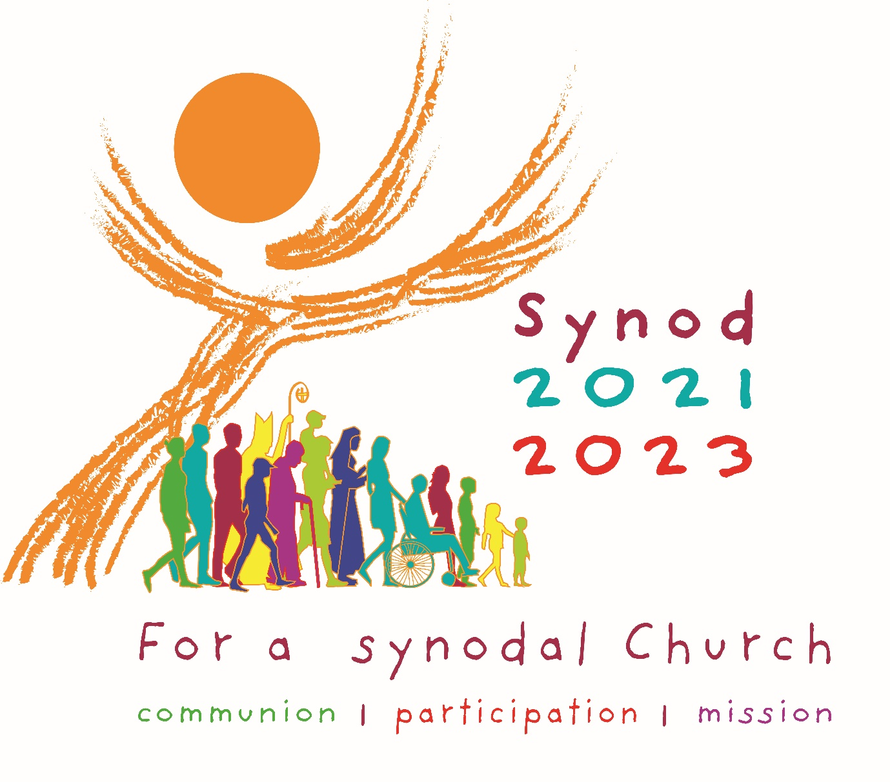

Parish Listening Sessions Synod Summary Report

This form is to be completed by the Parish Delegates, drawing on all the group listening sessions and activities that have taken place in the parish. It can be emailed to Synod@cliftondiocese.com or completed on-line at www.cliftondiocese.com/synod.

Parish Listening Session Synod Summary Report

Name of Parish and Deanery

Name of Parish Priest

Name of Parish Delegate filling out this form

Contact Details of Parish Delegate 1
Telephone number

Email Address

Additional Parish Delegates – Name and Email Address

Please provide a brief summary of your parish’s listening session for the Foundational Question:

A Synodal Church, in announcing the Gospel, “journeys together”. How is this “journeying together” happening today in your parish? How is the Holy Spirit inviting your parish community to grow in “Journeying together”? Where in these experiences do you hear the voice of the Holy Spirit.

0-1500 characters

Core Question 1 – Listening

How is God speaking to us through the voices that are in our midst? How is God speaking to us through voices we sometimes ignore, including those on the peripheries? What space is there to listen to the voices on the peripheries, especially cultural groups, women, the disabled, those who experience poverty, marginalisation, or social exclusion?

Core Question 2 – Speaking Out:

What enables or hinders you from speaking courageously, candidly, and responsibly in your parish and society. What space is there in your parish for the voice of people, including active and inactive members of our faith?

Core Question 3 – Sharing Responsibility for our Common Mission and Sharing Authority and participation

How are the baptised members of your parish able to participate in the mission of the Church to proclaim the Gospel? What hinders people from being active in your parish? How is authority or governance exercised in your local parish? How are teamwork and co-responsibility put into practice in your local parish?

Core Question 4 – Discerning and Deciding

How does your parish use the methods of listening and speaking (consultation) to make decisions? How does your parish promote participation in decision making within the hierarchical Church? Does the decision making of your parish help you to listen to all members of the community, including those who are on the peripheries of parish life?

Core Question 5 – Celebration

How do prayer and liturgical celebrations, especially Sunday Mass, inspire and guide your parish? How does your prayer life and celebration of the Mass inspire and inform your personal decisions and decisions in the parish community? How does the parish invite all baptised Catholics, including our ethnic communities, youth, families and persons with disabilities and their families, into the active life of the parish, especially Sunday Mass?

___________________________________________________________________________

