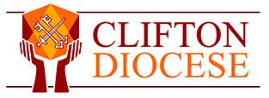

**Pastoral Ministry Formation Course**

**Application Form 2023-2026**

**Name:**

**Address**

**Contact Email (Please print)**

**Contact Telephone Number:**

**Name of Parish you usually attend:**

**Which course are you interested in – please tick which (if you are interested in both please tick both):**

Diploma in Pastoral Ministry which includes the Certificate in Pastoral Ministry from Loyola University, Chicago

Bishop’s Certificate in Pastoral Ministry Skills

**Current roles in the parish**

**Qualifications/ Courses/Training you have participated in within the diocese or elsewhere:**

**Reasons why you might like to develop your skills in pastoral ministry and what attracts you to this course in particular?**

**Any other information which you feel might be relevant to your application.**

**Important – Please note the dates for interviews if you are applying for the Loyola Certificate Course**

Preliminary Interviews 3rd July.

Short-listed Candidates will be invited back for interview on 11th or 12th July.

Please email your application to [sarah.adams@cliftondiocese.com](mailto:sarah.adams@cliftondiocese.com)